

Name:

Turing machine Exam Questions

Class:

Time:

Marks:

Comments:

**1**

A particular Turing machine has states S1, S2 and S3.

S1 is the start state and S3 is the stop state.

The machine uses one tape which is infinitely long in one direction to store data.

The machine’s alphabet is 0, 1, o, e and □, where □ is the symbol used to indicate a blank cell on the tape.

The transition rules for this Turing machine can be expressed as a transition function δ. Rules are written in the form:

δ(Current State, Input Symbol) = (Next State, Output Symbol, Movement)

So, for example, the rule:

δ (S1, 0) = (S1, 0, →)

|  |  |
| --- | --- |
| means |  |
| IF | the machine is currently in state S1 AND the input symbol read from the tape is 0 |
| THEN | the machine should remain in state S1, write a 0 to the tape and move the read/write head one cell to the right |

The machine’s transition function, δ, is defined by:

δ (S1, 0) = (S1, 0, →) δ (S1, 1) = (S2, 1, →) δ (S1, □) = (S3, e, →) δ (S2, 0) = (S2, 0, →) δ (S2, 1) = (S1, 1, →) δ (S2, □) = (S3, 0, →)

The diagram below shows a partially labelled finite state transition diagram for this machine.

Some labels are missing and have been replaced by numbers such as . Each state transition arrow is labelled with the input symbol, the output symbol and the direction of movement, in that order. For example (□, e, →) means that if the input symbol is □, an e is written to the tape and the read/write head moves right one cell.

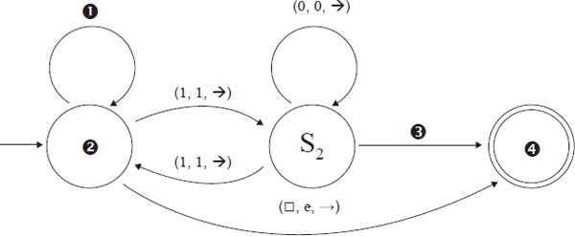

1. Four labels are missing from the diagram above.

Write the missing labels in the table below.

|  |  |
| --- | --- |
| **Number** | **Correct Label** |
|  | 0, 0, --> |
|  | S1 |
|  | Blank, o, --> |
|  | S3 |

**(2)**

1. The Turing machine is carrying out a computation using one tape which is infinitely long inone direction. The machine starts in state S1 with the string 01100 on the tape.

All other cells contain the blank symbol, □. The read/write head is positioned at the leftmost zero, as indicated by the arrow.

 Current State:

Trace the computation of the Turing machine, using the transition function δ. Show the contents of the tape, the current position of the read/write head and the current state as the input symbols are processed.

  Current State:

  Current State:

  Current State:

  Current State:

  Current State:

  Current State:

**(4)**

1. What is the purpose of the algorithm represented by this Turing machine?

........................................................................................................................

........................................................................................................................

........................................................................................................................

**(1)**

1. Explain the importance of the theory of Turing machines to the subject of computation.

........................................................................................................................

........................................................................................................................

........................................................................................................................

........................................................................................................................

........................................................................................................................

**(2)**

**(Total 9 marks)**

**2**

A particular Turing machine has states S1, S2, S3 and S4. S1 is the start state and S4 is the stop state. The machine uses one tape which is infinitely long in one direction to store data. The machine’s alphabet is 1, □. The symbol □ is used to indicate a blank cell on the tape.

The transition rules for this Turing machine can be expressed as a transition function δ. Rules are written in the form:

δ(Current State, Input Symbol) = (Next State, Output Symbol, Movement)

So, for example, the rule:

δ (S1, 1) = (S1 , 1, → )

means:

IF the machine is currently in state S1 AND the input symbol read from the tape is 1

THEN the machine should remain in state S1, write a 1 to the tape and move the read/write head one cell to the right

The machine’s transition function, δ, is defined by:

δ (S1, 1) = (S1 , 1, → )

δ (S1, □) = (S2 , □, ← )

δ (S2, 1) = (S3 , □, ← )

δ (S3, 1) = (S4 , □, ← )

(a) The Turing machine is carrying out a computation. The machine starts in state S1 with the string 1111 on the tape. All other cells contain the blank symbol, □. The read/write head is positioned at the leftmost 1, as indicated by the arrow.

Current State:

Trace the computation of the Turing machine, using the transition function δ. Show the contents of the tape, the current position of the read / write head and the current state as the input symbols are processed.

  Current State:

  Current State:

  Current State:

  Current State:

  Current State:

  Current State:

  Current State:

**(6)**

1. Explain what this Turing machine does.

........................................................................................................................

........................................................................................................................

**(1)**

1. Explain what a *Universal Turing machine* is.

........................................................................................................................

........................................................................................................................

........................................................................................................................

........................................................................................................................

........................................................................................................................

**(2) (Total 9 marks)**

**3**

A particular Turing machine has states SB, S0, S1, SR and ST. SB is the start state and ST is the stop state. The machine stores data on a single tape which is infinitely long in one direction. The machine’s alphabet is 0, 1, #, x, y and □ where □ is the symbol used to indicate a blank cell on the tape.

The transition rules for this Turing machine can be expressed as a transition function δ. Rules are written in the form:

δ(Current State, Input Symbol) = (Next State, Output Symbol, Movement) So, for example, the rule: δ(SB, 1) = (S1, y, →)

means:

IF the machine is currently in state SB AND the input symbol read from the tape is 1

THEN the machine should change to state S1, write a y to the tape and move the read/ write head one cell to the right

The machine’s transition function, δ, is defined by:

|  |  |
| --- | --- |
| δ (SB, 0) = (S0, x, →) δ (SB, 1) = (S1, y, →) δ (SB, #) = (ST, #, →)  δ (S0, 0) = (S0, 0, →)    δ (S0, 1) = (S0, 1, →) δ (S0, #) = (S0, #, →) δ (S0, □) = (SR, 0, ←) | δ (S1, 0) = (S1, 0, →) δ (S1, 1) = (S1, 1, →) δ (S1, #) = (S1, #, →) δ (S1, □) = (SR, 1, ←)  δ (SR, 0) = (SR, 0, ←) δ (SR, 1) = (SR, 1, ←) δ (SR, #) = (SR, #, ←) δ (SR, x) = (SB, 0, →) δ (SR, y) = (SB, 1, →) |

**Figure 1** shows an unlabelled finite state transition diagram for this machine. Some of the state transition arrows represent more than one of the machine’s transition rules. For example, the arrow labeled ❶ represents the three rules: δ (S0, 0) = (S0, 0, →), δ (S0, 1) = (S0, 1, →) and δ (S0, #) = (S0, #, →).

**Figure 1**

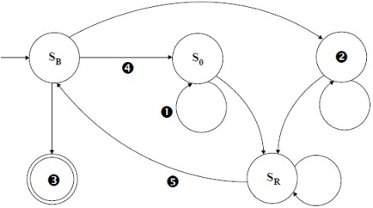

1. (i) Which states are represented by the labels ❷ and ❸ in **Figure 1**?

❷ ......................... ❸ .........................

**(1)**

* 1. Which of the machine’s transition rule(s) is / are represented by the arrow labelled ❹ in **Figure 1**?

...............................................................................................................

...............................................................................................................

**(1)**

* 1. Which of the machine’s transition rule(s) is / are represented by the arrow labelled ❺ in **Figure 1**?

...............................................................................................................

...............................................................................................................

**(1)**

The machine's transition rule, δ, is repeated here so that you can answer part **(b)** without having to turn back in the question paper booklet.

|  |  |
| --- | --- |
| δ (SB, 0) = (S0, x, →) δ (SB, 1) = (S1, y, →) δ (SB, #) = (ST, #, →)  δ (S0, 0) = (S0, 0, →)    δ (S0, 1) = (S0, 1, →) δ (S0, #) = (S0, #, →) δ (S0, □) = (SR, 0, ←) | δ (S1, 0) = (S1, 0, →) δ (S1, 1) = (S1, 1, →) δ (S1, #) = (S1, #, →) δ (S1, □) = (SR, 1, ←)  δ (SR, 0) = (SR, 0, ←) δ (SR, 1) = (SR, 1, ←) δ (SR, #) = (SR, #, ←) δ (SR, x) = (SB, 0, →) δ (SR, y) = (SB, 1, →) |

1. This Turing machine is carrying out a computation. The machine starts in state SB with the string 01# on the tape. All other cells contain the blank symbol, □ (not shown).

Trace the computation of the Turing machine, using the transition function δ. Show the contents of the tape, the current position of the read / write head and the current state as the input symbols are processed. The first three steps and final state have been completed for you.

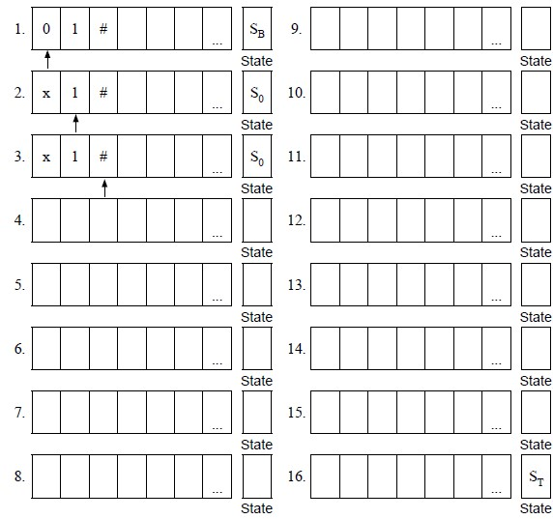

**(6)**

1. Describe the purpose of the symbols x and y in this Turing machine’s alphabet.

...............................................................................................................

...............................................................................................................

**(1)**

1. What does the Turing machine do?

...............................................................................................................

...............................................................................................................

**(1) (Total 11 marks)**

**4**

A Turing machine has been designed to recognise palindromic binary numbers, ie numbers such as 101 and 0110 that read the same from left to right as from right to left.

The machine has states SB, S0, S1, SC0, SC1, SL, SY and SN.

SB is the start state and SY and SN are the stop states.

The machine stores data on a single tape which is infinitely long in one direction. The machine’s alphabet is 0, 1 and **□**, where **□** is the symbol used to indicate a blank cell on the tape. The machine will enter state SY if the value represented on the tape is a palindromic binary number, otherwise it will enter state SN.

The transition rules for this Turing machine can be expressed as a transition function δ. Rules are written in the form:

δ(Current State, Input Symbol) = (Next State, Output Symbol, Movement)

So, for example, the rule:

δ (SB, 0) = (S0 , **□**, →)

means:

IF the machine is currently in state SB AND the input symbol read from the

tape is 0

THEN the machine should change to state S0, write a blank symbol (**□**) to the tape

and move the read / write head one cell to the right

The machine’s transition function, δ, is defined by:

δ (SB, 0) = (S0, □, →) δ (SC0, 0) = (SL, □,←) δ (SB, 1) = (S1, □, →) δ (SC0, 1) = (SN, 1,←) δ (SB, □) = (SY, □, →) δ (SC0, □) = (SY, □,→)

δ (S0, 0) = (S0, 0, →) δ (SC1, 0) = (SN, 0, ←) δ (S0, 1) = (S0, 1, →) δ (SC1, 1) = (SL, □, ←) δ (S0, □) = (SC0, □, ←) δ (SC1, □) = (SY, □, →)

δ (S1, 0) = (S1, 0, →) δ (SL, 0) = (SL, 0, ←)

δ (S1, 1) = (S1, 1, →) δ (SL, 1) = (SL, 1,←) δ (S1, □) = (SC1, □, ←) δ (SL, □) = (SB, □,→)

1. This Turing machine is carrying out a computation. The machine starts in state SB with the string 101 on the tape. All other cells contain the blank symbol, **□** (not shown).

The read / write head is located at the left hand symbol of the string and is indicated with an upward arrow.

Trace the computation of the Turing machine, using the transition function δ.

Show the contents of the tape, the current position of the read/write head and the current state as the input symbols are processed.

The initial configuration of the machine has been completed for you in step 1.

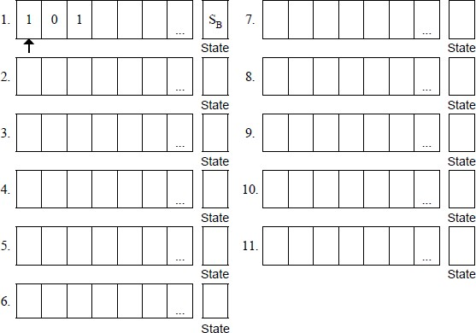

**(5)**

1. The three rules shown below are part of the machine’s transition function.

Explain what effect these three rules, taken together, have on the tape, the read / write head and the state of the Turing machine:

δ (S0, 0) = (S0, 0, →) δ (S0, 1) = (S0, 1, →) δ (S0, **□**) = (SC0, □,←)

........................................................................................................................

........................................................................................................................

........................................................................................................................

........................................................................................................................

........................................................................................................................

**(2)**

(c) A Universal Turing machine (UTM) is a special type of Turing machine that can be considered to act like an interpreter.

Explain how a UTM can be considered to be an interpreter.

........................................................................................................................

........................................................................................................................

........................................................................................................................

........................................................................................................................

**(2)**

**(Total 9 marks)**

**5**

The diagram below shows a Finite State Automaton (FSA). The FSA has input alphabet {a, b, c} and six states, S₁, S₂, S₃, S₄, S₅ and S₆.

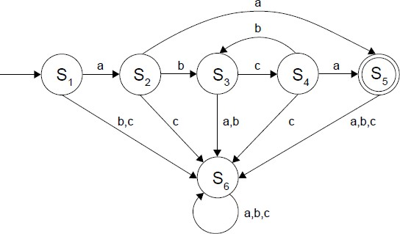

1. Complete the empty cells in the **part of the transition table shown** below for the FSA in the diagram.

|  |  |  |  |  |  |  |  |  |  |
| --- | --- | --- | --- | --- | --- | --- | --- | --- | --- |
| **Current State** | S₁ | S₁ | S₁ | S₂ | S₂ | S₂ | S₃ | S₃ | S₃ |
| **Input Symbol** | a | b | c | a | b | c |  |  |  |
| **Next State** | S₂ | S₆ | S₆ | S₅ | S₃ | S₆ |  |  |  |

**(1)**

1. Give the name of the state that the FSA will end up in when processing the string abcb.

........................................................................................................................

**(1)**

1. Describe the purpose of state S₆.

........................................................................................................................

........................................................................................................................

**(1)**

1. The FSA in the diagram above accepts strings that consist of:
   * a letter a
   * followed by zero or more occurrences of the string bc and
   * ending with a second letter a.

For any FSA, it is possible to write a regular expression that will match the same language (set of strings) as the FSA.

Write a regular expression that will match the same language that is accepted by the FSA above.

........................................................................................................................

........................................................................................................................

**(2)**

1. The Turing Machine is a more powerful abstract model of computation than the FSA.

Explain why the Turing Machine model can be used to recognise a greater range of languages than an FSA could.

........................................................................................................................

........................................................................................................................

**(1) (Total 6 marks)**

Mark schemes

**1**

|  |  |
| --- | --- |
| **Number** | **Correct Label** |
|  | (0, 0, →) |
|  | S1 |
|  | ( , o, →) |
|  | S3 |

(a)

*1 mark for 1 and 3 correct – brackets not required*

*1 mark for 2 and 4 correct*

**2**

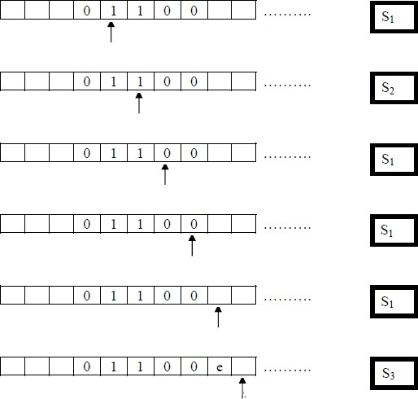(b)

*Mark to end, do not stop at first mistake.*

*1 mark for first row correct;*

*1 mark for second row correct;*

*1 mark for both rows three and four correct;*

*1 mark for both rows five and six correct;*

*Must have correct tape contents and current state for each mark*

**A** answers where the tape has been shifted

**DPT** for missing read/write head

**4**

1. Check if the tape contains an even / odd number of 1s // check parity of number ontape;

**1**

1. Turing machines provide a (general/formal) model of computation;

Provides a definition of what is computable // a task is computable if (and only if) it can be computed by a Turing machine;

No computing device can be more powerful than a Turing machine // any algorithm that can be computed by any computer can be computed by a Turing machine; (The Church–Turing thesis states that) if an algorithm exists then there is an equivalent Turing machine for that algorithm // a Turing machine that can implement the algorithm;

Through the Halting Problem, can be used to prove that some functions cannot be computed;

**Max 2**

**[9]**

**2**

(a)

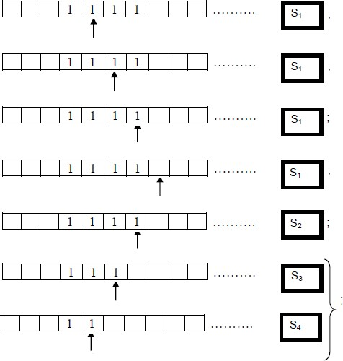

*1 mark for each of the top five rows*

*1 mark for sixth and seventh row together*

*Must have correct tape contents and state for each mark*

**A** the blank cell symbol □ in blank cells

**A** answers in which the initial situation of the TM is repeated

**A** If the read/write head is not drawn on some rows, this should result in the loss of the mark on the first occasion that it is missing only.

*Marks should be awarded for subsequent rows, even if the read / write head is not drawn.*

**6**

1. Deletes two ones from the (right hand) end of the string //

Subtracts two from a (unary) number;

* 1. bits for ones

**R** end of tape for end of string

**NE** deletes two ones

**1**

1. A Turing machine that can execute/simulate the behaviour of any other Turingmachine // can compute any computable sequence;

Faithfully executes operations on the data precisely as the simulated TM does; (Note:

Must have idea of same process)

Description of/Instructions for TM (and the TM's input) are stored on the (Universal

Turing machine's) tape // The UTM acts as an interpreter;

* 1. take any other TM and data as input**Alternative definition:**

A UTM, U, is an interpreter that reads the description <M> of any arbitrary Turing machine M; and faithfully executes operations on data D precisely as M does.; The description <M> is written at the beginning of the tape, followed by D.;

**Max 2**

**[9]**

**3**

1. (i) ❷ S1 **A** 1, State 1

❸ ST **A** T, State T

Both answers correct to get mark;

**1**

(ii) δ (SB, 0) = (S0, x,→);

**A** 0, x, → or 0 | x | →;

**R** if additional rules listed

**I** minor transcription errors e.g. missing , ( δ

**1**

(iii) δ (SR, x) = (SB, 0,→ ) and δ (SR, y) = (SB, 1, →);

**A** x, 0, → or x | 0 | → and y, 1, → or y | 1 | →

**R** if additional rules listed

**I** minor transcription errors e.g. missing , ( δ

**1**

1. One mark per bracketed section.

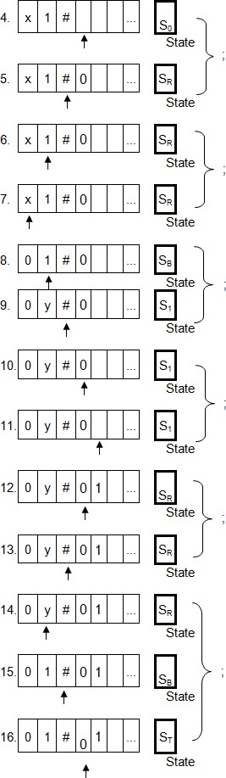

**Must have correct tape contents and state for each mark**

**A** blank symbols instead of empty cells

**DPT** If the read / write head is not drawn on some rows, this should result in the loss of the mark on the first occasion that it is missing only.

Marks should be awarded for subsequent rows, even if the read / write head is not drawn.

**6**

1. (i) Mark symbol currently being copied // to indicate how much of the string hasbeen copied so far // to indicate where to return to (to copy next symbol);

**A** placeholders

**NE** x represents 0, y represents 1

**1**

(ii) Copy a string // copy a binary number // copy a bit pattern; **A** Repeat

**1**

**[11]**

**4**

* 1. **1 mark** per bracketed section.

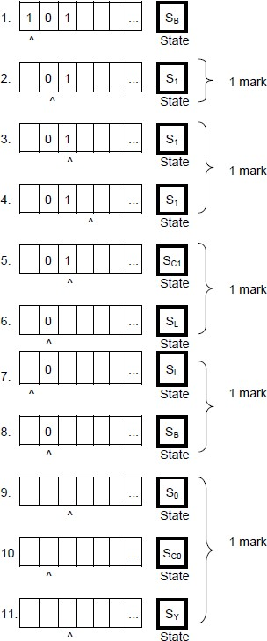

**Must have correct tape contents and state for each mark**

**A** blank symbols instead of empty cells

**DPT** If the read / write head is not drawn on some rows, this should result in the loss of the mark on the first occasion that it is missing only. Marks should be awarded for subsequent rows, even if the read / write head is not drawn.

**5**

* 1. (After a 0 has been read,) the rules keeps moving the read / write head to the right

(preserving the contents of the tape);

Until a blank symbol is encountered / the end of the number is reached, then the state is changed to SC0 (and the head is moved left / direction reversed);

**Note**: To achieve the first mark, it must be clear that the head moves right regardless of whether a 0 or 1 is read and also that this is a repeated process ie not just moving one place right.

**Note**: If it is stated that the process of moving continues until the end of the number is reached, then it can be inferred that the head was moving right for the first mark, if this was not explicitly stated.

**Note**: Marks should not be awarded for just explaining what the rules do individually.

**2**

(c) It reads instructions one at a time / / reads instructions in sequence / / deals with instructions line by line;

And executes these instructions;

Instructions are / transition function is stored on the tape;

**A** "rules" for "instructions"

**MAX 2**

**2**

**[9]**

**5**

(a)

|  |  |  |  |
| --- | --- | --- | --- |
| **Current**  **State** | S₃ | S₃ | S₃ |
| **Input**  **Symbol** | a  S₆ | b  S₆ | c  S₄ |
| **Next State** |

**1 mark** for all six correct values in the bold rectangular area

The columns do not have to be in the same order as shown, but the pairings must be correct i.e. (a - S₆, b - S₆, c - S₄).

**A** 4 for S₄ and 6 for S₆

**1**

1. S₃
   1. 3

**I** An additional name given to the state eg “State 3”

**1**

1. To ensure that a non-valid string is trapped // prevent the accepting state beingreached;
   1. To capture invalid input

**A** To capture strings that are too long / have extra characters

**NE** Infinite loop / state cannot be left

**1**

1. a(bc)*a // a(bc)+?a // (aa)|(a(bc)*a) //

(aa)|(a(bc)+?a) // (aa)|(a(bc)+a)

**1 mark** for recognising an a at both ends

**1 mark** for correctly recognising 0 or more repetitions of bc

**I** ^ and $ at start and end of expression

**A** Any type of bracket

**2**

(e) Turing Machine has (an infinite / unlimited amount of) memory / storage;

Turing Machine can read and write / input and output (data) to / from a tape;

Turing Machine has infinitely long tape;

**NE** Turing Machine has a tape

**MAX 1**

**1**

**[6]**

Examiner reports

**1**

Part (a): The vast majority of candidates scored both marks for this question. Candidates who only scored one mark usually named the states correctly.

Part (b): Most candidates gained some of the four available marks and over half gained all four. Some chose to keep the position of the tape head fixed and move the tape, rather than vice-versa which was perfectly acceptable.

Part (c): The Turing machine outputted 'e' if the tape contained an even number of ones and ‘o’ if the number of ones was odd. Determining this was a difficult task given the limited trace that candidates were asked to complete. Nevertheless a quarter of candidates were able to do this. Many who did not get the correct answer had managed to understand that the use of the Turing machine related to evenness but that this was whether the number itself was odd or even. A commonly made mistake was to assume that the output of the Turing machine depended only on whether the last digit read was a 0 or 1.

Part (d): It was pleasing to see that many candidates understood that a problem is computable if and only if it can be computed by a Turing machine. Some went on to make a further point, such as that no computer could be more powerful than a Turing machine, but answers scoring both marks were rare.

**2**

Part (a): This question part was very well answered. The majority of candidates knew how to trace the execution of a Turing machine and many got full marks. The two most common mistakes were to change into state S2 on the fourth transition, i.e. when the head moved right into the first blank cell, and to start to delete 1s on the fifth transition, i.e. when the head moved left for the first time.

Part (b): The Turing machine deleted the rightmost two 1s from the end of the string on the tape. This was recognised by a third of the candidates. Some however made assertions that were too vague to be creditworthy, such as, “deletes two ones from the tape,” or, “erases the string.” An alternative valid answer was that the Turing machine subtracted two from a unary number. A small number of candidates referred to the end of the tape. Such responses were rejected as the tape is infinitely long.

Part (c): A Universal Turing machine (UTM) is a Turing machine that can simulate the behaviour of any other Turing machine. A description of the Turing machine that is being simulated, including the instructions that the machine follows, is written onto the tape of the UTM. The UTM then acts as an interpreter, faithfully executing the operations on the data exactly as the original Turing machine would have. The two most common mistakes that candidates made were to describe an ordinary Turing machine rather than a Universal Turing machine and to state that a UTM would control another Turing machine rather than simulate it.

**3**

For (a), the vast majority of candidates correctly identified the states and rules from the Turing machine's transition function.

For part (b), as in previous years, the trace of the Turing machine's computation was very well completed. This was particularly pleasing as the transition function was longer and the trace more complex than on previous papers. Approximately three quarters of candidates achieved full marks for this question part.

For part (c)(i), candidates needed to recognise that the x and y symbols were used as placeholders for 0 and 1 so that the Turing machine could identify how much of the string had been processed to achieve a mark. Many fell slightly short of this by recognising the x replaced 0 and y replaced 1, but not explaining the purpose of this replacement.

For part (c)(ii) the majority of candidates explained correctly that that Turing machine could be used to copy binary strings on the tape. Some candidates missed out on the mark by just explaining what the Turning machine had done in this specific execution i.e. “writing 01" to the tape, rather than explaining its more general function. A small number of candidates gave answers taken from previous mark schemes which did not relate to this question.

**4**

1. This part was a trace of the execution of a Turing machine. This was very well tackled withover three quarters of students achieving full marks.
2. This part required students to explain the overall effect of three of the rules of the Turingmachine’s transition function. The overall effect was that the tape head would move right along the string until the end of the string was found, without changing the contents of the tape. When the end of the string was located, the state would change to SCO and the head would move left. The most common mistake that students made was to explain what each individual rule did rather than what the purpose of the rules taken together was.
3. This part was poorly tacked, with only slightly over a quarter of students achieving anymarks. A universal Turing machine can be seen to work as an interpreter because it reads instructions in order from a tape and executes them in sequence. This is similar to how an interpreter reads instructions in order from memory and executes them in sequence. Many students either defined what a universal Turing machine was, or answered the question that has been asked on a previous paper about the importance of them.

**5**

This question was about models of computation. Question parts (a) and (b) were both extremely well answered with almost all students demonstrating a basic understanding of Finite State Automata by being able to complete the transition table and identify the state correctly.

For part (c) many students were able to identify that there was no way for any string which caused the FSA to enter state S6 to ever move the FSA to a different state, but to achieve the mark students needed to explain that this was to prevent invalid strings from being accepted, and only around half of students did this successfully. Students sometimes stated that the state would cause the machine to stop or described it incorrectly as a halting state.

Students’ understanding of regular expressions has improved significantly during the lifetime of this specification, and it was pleasing to see in part (d) that approximately three quarters of students wrote a fully correct regular expression. Common mistakes were to use the + operator instead of the * or to misunderstand the scope of the * operator.

For part (e) students were required to explain why a Turing machine was more powerful than an

FSA. Good responses recognised that the key difference was the infinite length tape that the Turing machine has, which could be used as an unbounded memory. Whilst an FSA can use its states as a form of memory, this is by definition finite. A commonly seen but incorrect response was that no model of computation could be more powerful than a Turing machine. This explained why a Turing machine was at least as powerful as an FSA, but not why it was more powerful.